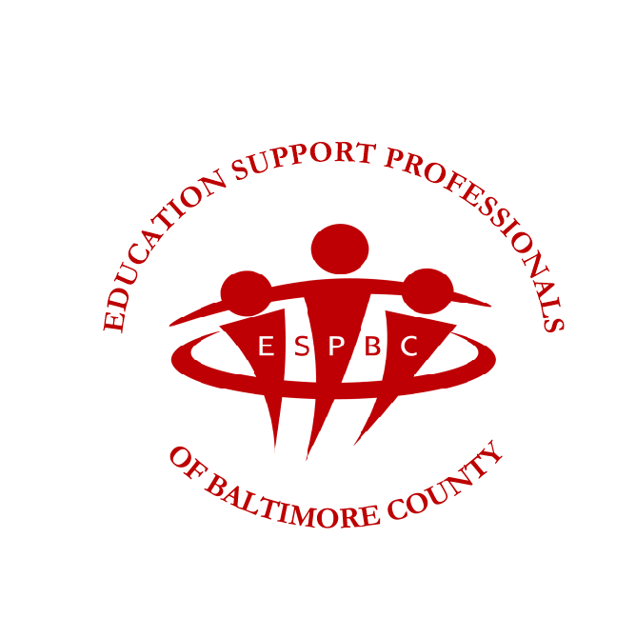
Education Support Professionals
of Baltimore County

SCHOLARSHIP AVAILABLE:

ESPBC MEMORIAL SCHOLARSHIP - $500
In honor of former Baltimore County ESPBC members through the generosity and dedication of persons who actively work to further the education of youth.

GENERAL INFORMATION

If eligible, parent MUST have been an ESPBC member for at least three full school years prior to student application for scholarship funds.

* The scholarship will be awarded on the basis of need, as well as academic and community achievement regardless of choice of profession, only to members or children whose parents/grandparents
a. are active ESPBC members.
b. were active members of ESPBC at the time of retirement.
* The scholarship is given for a one-year period and may be considered for renewal upon reapplication.
* The recipient must be entering or enrolled in an undergraduate program in a college or university accredited by its regional association.
* Applications may be secured from the ESPBC Office by contacting Jacque Gerhardt at jgerhardt@mseanea.org or our website at www.espbc.org.

The applicant must:

1. Complete the application form.
2. Submit a formal letter of interest telling why the scholarship is needed, listing any scholastic awards, extra curricular activities, and participation in community services.
3. Submit two letters of character reference written by individuals other than teachers or school administrators.
4. Submit three letters of academic references written by individuals who have taught and/or counseled the student in school.
5. The student must request that a transcript of his/her high school or college record be sent to the ESPBC Scholarship Committee.
NOTE: Please include only requested items.

All required information must be received in the ESPBC Office by March 31, 2025. You may return your information (electronically to Jacqueline Gerhardt at jgerhardt@mseanea.org or by fax to 410-337-7081 or by mail.)

Applications will be screened by the ESPBC Scholarship Committee and recommendations made to the ESPBC Board of Directors.

High school recipients will be notified at their high school awards program or June 18th, whichever comes first. College recipients will be notified by mail by June 18th.

